System Security: Lab Manual

MS Cyber Security

ITU Lahore



Submitted to: Muhammad Shehryar Raza

Submitted By: Eisha Nawaz

Roll No: MSCS22007

Lab 14: Secure API Authentication – JWT Attacks & Defenses
Duration: 2 Hours
Mode: Group-based (Client / Attacker / API Maintainer)
Tools:
- Postman or cURL
- JWT.io
- Vulnerable REST API (provided)

1. Learning Objectives
Students will:
- Understand JWT structure
- Exploit weak token validation
- Perform privilege escalation
- Implement cryptographic signing defenses

2. Scenario Description
An API uses JWT-based authentication but fails to properly validate token signatures.
Attackers may modify claims to gain admin access.

3. Group Roles
- Client: Uses API legitimately
- Attacker: Modifies JWT
- Maintainer: Fixes validation

4. Environment Setup
Api.ppy
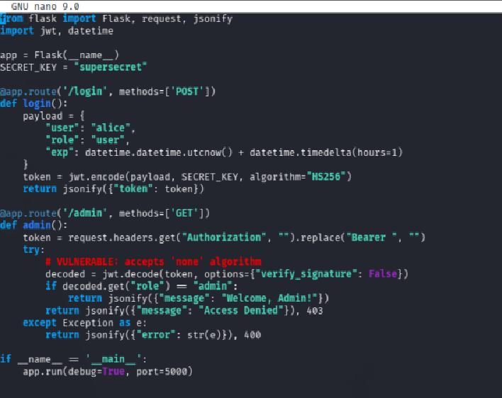
Start API server:
python api.py
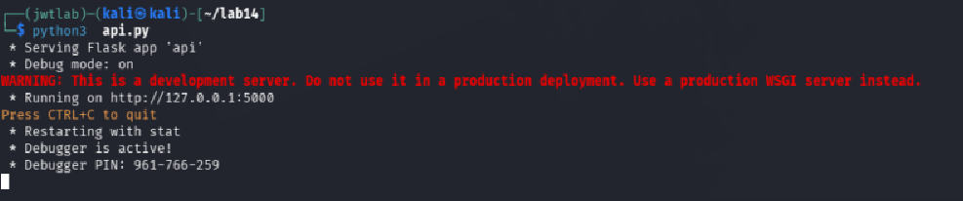
Authenticate:
curl -X POST /login
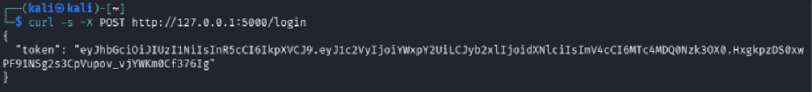
Receive JWT token.

5. Step-by-Step Tasks

Task 1: Decode JWT
Paste token into:
- https://jwt.io
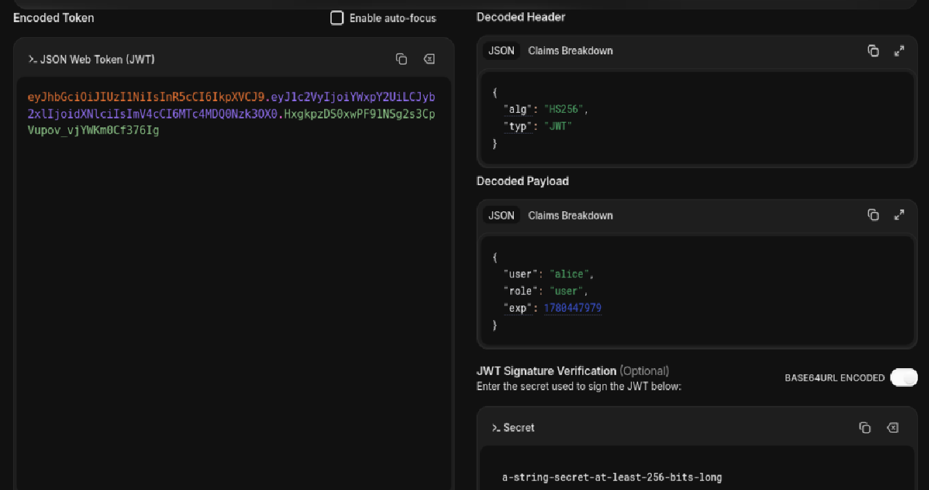
Identify:
- Header:
{
"alg": "HS256",
"typ": "JWT"
}
- Payload
{
"user": "alice",
"role": "user",
"exp": 1780447979
}
- Signature
a-string-secret-at-least-256-bits-long

Task 2: Token Tampering
Temper.py
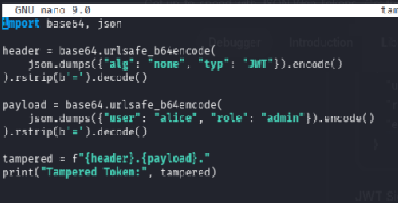
Modify payload:
"role": "admin"
Remove or change signature.
Replay request:
curl -H "Authorization: Bearer <tampered-token>" /admin
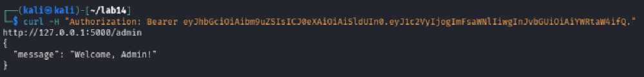
unauthorized access confirmed!.

Task 3: Root Cause Analysis
Answer:
- Why tampering worked
The server used verify_signature: False, so it never checked the signature
- Which validation step was missing
Signature verification and algorithm enforcement.

Task 4: Implement Signing Defense
Update api.py
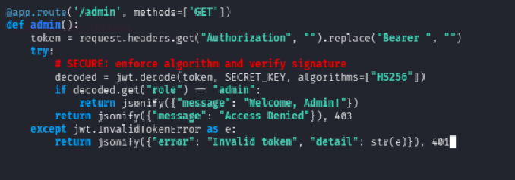
Enable:
- HS256 or RS256 signing
- Signature verification
Again starting server
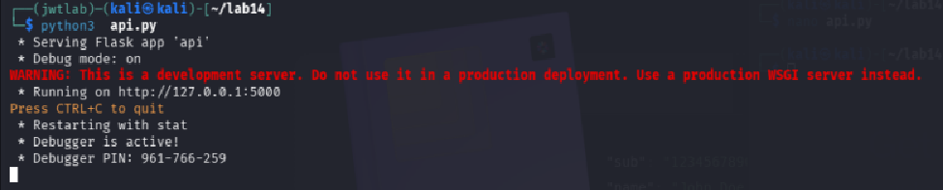
Tempered Token Rejected 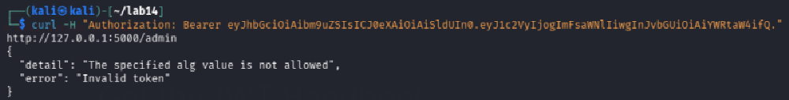
Valid Token Accepted
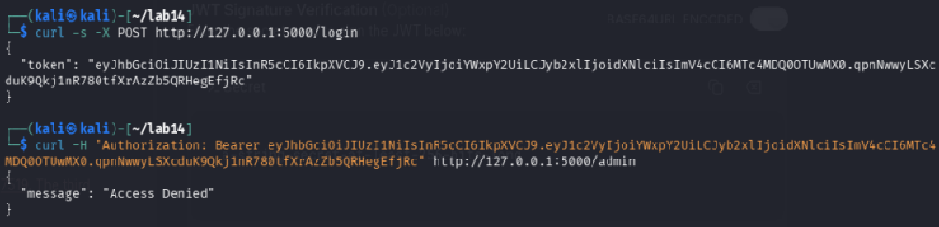

Task 5: Security Reflection
Answer:
- Why JWT ≠ encryption
JWT is Base64-encoded, not encrypted, anyone can read the payload. Use JWE for encryption.
- Why claim trust is dangerous
If signatures aren't verified, any client can forge claims like "role": "admin"
- Common JWT mistakes in industry
Using alg: none, weak secrets, not checking expiry (exp), trusting client-side claims

